Chapter 13: 1850-1869 The Crinoline Period

1. Barege - Abby Fluckiger

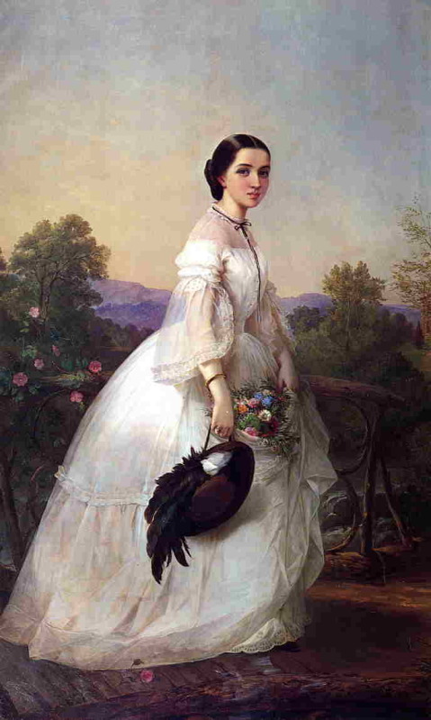 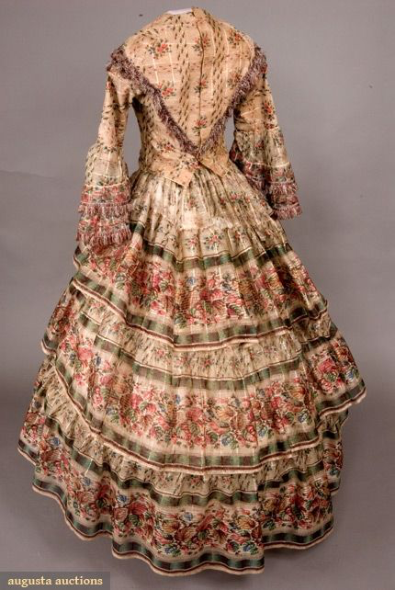

Barege was a lightweight, sheer fabric akin to gauze, made of a silk and wool blend. The name comes from a town in France, Barèges, where the fabric supposedly originated. Thanks to its gauzy, see-through nature, it was reserved for warm weather and evening dress, and only for women.

Sources:

Textbook page 364

<https://en.wikipedia.org/wiki/Barege>

<http://gbacg.org/finery/2015/sheer-delight-sheer-dresses-of-the-crinoline-era/>

1. Basque- Lauren Shumway 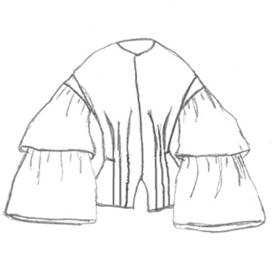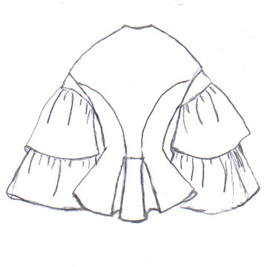

A jacket like garment that was cut to have extensions to flare out at the waist general buttoned up the front and frills where encouraged

The Book p.363

<https://glcp.uvm.edu/landscape_new/dating/clothing_and_hair/1850s_clothing_women.php>

<http://www.katetattersall.com/victorian-fashion-terms-a-m/>

1. Bloomer - Irelynd Preece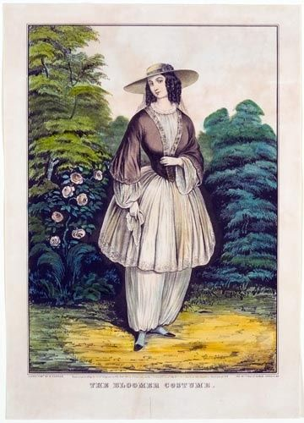

From this period on the word Bloomer described any loose, full, trouser-like garment which is gathered at some point between the knee and ankle. These bloomers were worn under long skirts and could often be seen. The reason behind this design was to preserve a Victorian woman’s modesty while also providing freedom of movement in household activities. These bloomers were named after the woman, Mrs. Bloomer. She was part of the feminist movement, and only a few women outside of the feminist movement took up bloomers. This caused ridicule which then lead some feminists to conclude that the bloomers were counterproductive.

Sources:

Textbook page 359

<https://fashionhistory.fitnyc.edu/bloomers/>

<http://www.victoriana.com/bloomer-costume/>

1. Blue
2. Braces - Debbi Wright

In our textbook we learn that in England “braces” are what we call in the United States, suspenders. These were used to hold men’s trousers up. It was at the time also acceptable for a lady to give as a gift a set of suspenders to a gentleman. They were often embroidered when given as a gift as shown in the first picture. In the second picture the braces are a replica of what was used during the Civil War in the United States.

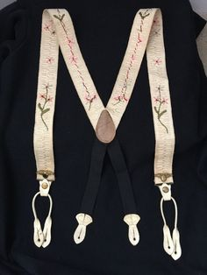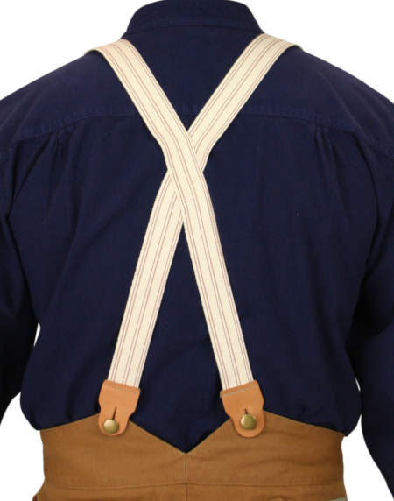

Toratora, Phyllis G, and Keith Eubank. *Survey of Historic Costume, 5th Edition*. Berg, 2009

<https://www.pinterest.com/beverlydomenget/suspenders-1860-era/>

<https://www.historicalemporium.com/store/007660.php?gclid=Cj0KCQiA09eQBhCxARIsAAYRiykHIuqr0uBMyl4PZgLNwUwOYbq5fBfON-lBrsWgpW5V5POQgkZTbbQaAv8cEALw_wcB>

1. Cage Crinoline-Anna Ament

Cage Crinoline

The Cage Crinoline was a type of wire hoop worn under a woman's skirt in order to create a round silhouette and enhance the appearance of a tiny waist. The material was a type of steel that was bendable and did not include any fabric. Women of all classes wore the cage crinoline under their dresses.

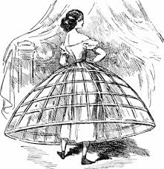

<https://www.britannica.com/topic/petticoat>

<https://fashionhistory.fitnyc.edu/cage-crinoline/>

1. Chambre Syndicale de la Couture Parisienne- Abbie Burns

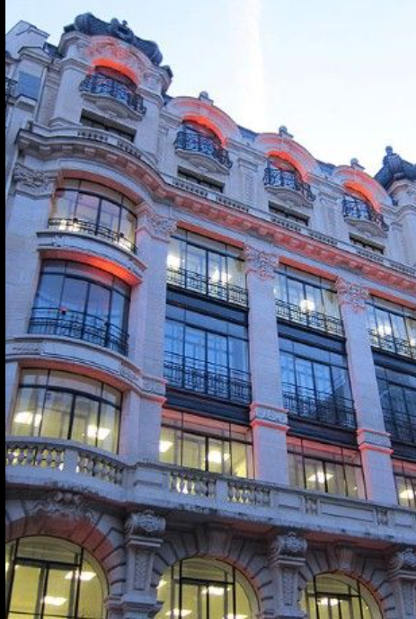

This was an organization for countries who are involved in French Couture to become considered “haute couture” or not. It shut down after World War II. This organization was started by Charles Fredrick Worth. The Chambre would regulate various fashion design houses to see who is eligible to be a true haute couture house. To classify as “Haut Couture” You must be able to make 50 new designs for the day and evening wear for each collection and be in two shows a year. You also must employ 20 people full-time in your workshop. Today some similar requirements take place. You still walk the runway in two shows a year with 35 pieces in each show. You must have an atelier in Paris and 15 full-time employees working there.

Sources:

Book: pg:354

<https://fashion-era.com/fashion-history/chambre-syndicale/>

https://observer.com/2016/01/couture-101-the-basics-of-haute-couture/

1. Fichu- Kya Boyd

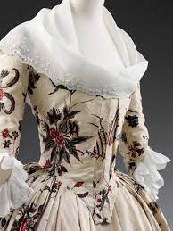 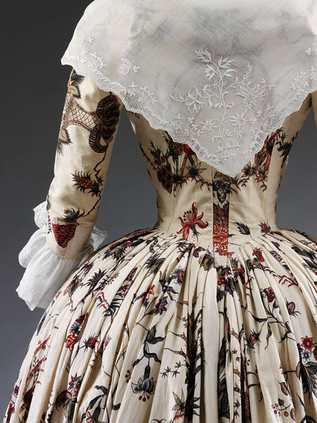

Fichu is a term that replaced the handkerchief or neckerchief for women, worn around the neck and shoulders. This style of scarf continued to trend into the nineteenth century then as fashions shifted chests were covered by large shawls and scarfs as accessories. In this era influenced by the romantic era; bodices were cut in a low revealing length causing women to require a fichu to cover their chest. Fichus were either square or triangular shapes worn around the neck crossing or tying the extra length around the bosom. They were often made out of white cotton or linen decorated with whitework embroidery, but others were made with colorful silks and rich embroidery.

Sources:

<https://fashionhistory.fitnyc.edu/fichu/>

<https://pieceworkmagazine.com/what-is-a-fichu/>

“Survey of Historic Costume” Page 365

1. Frock Coat- Jessica Fraser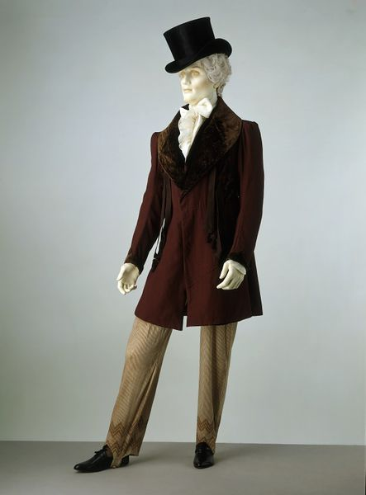

The Frock Coat is a man's coat that has a collar. It was a big thing through the eighteenth and twentieth century. It had buttons that went all the way down and that it draped down the upper legs. It flows like a skirt after it hits the waist. It was made from linen, cotton, and wool. It was very comfortable.

The Book

<https://fashionhistory.fitnyc.edu/frock-coat/#:~:text=The%20frock%20coat%20is%20a,the%20body%20like%20a%20skirt>

[(Links to an external site.)](https://fashionhistory.fitnyc.edu/frock-coat/#:~:text=The%20frock%20coat%20is%20a,the%20body%20like%20a%20skirt)

<https://en.wikipedia.org/wiki/Frock_coat>

[(Links to an external site.)](https://en.wikipedia.org/wiki/Frock_coat)

1. Garibaldi- Samantha Hooper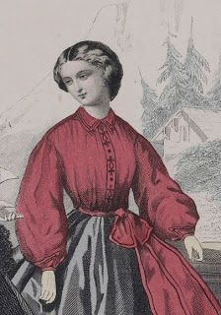

The Garibaldi blouse was a red blouse worn by women with skirts. They had high necks and closed sleeves. It was named after the Italian General Giuseppe Garibaldi, who, along with his troops, wore a similar style of red shirt. The Garibaldi shirt was worn by women, girls, and boys.

<https://en.wikipedia.org/wiki/Garibaldi_shirt>

http://www.victoriana.com/garibaldi-shirt/

1. Inverness Cape and a tall collar stand - Claire Lynes

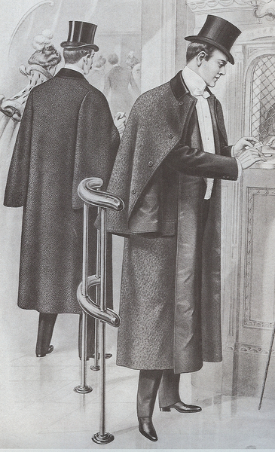

The Inverness Cape was an outer coat with long sleeves that were covered by a cape. This cape was as long as the sleeves. The Inverness cape was made of wool and was black or a dark color. The Inverness cape sometimes had short lapels but most commonly just had a tall collar stand and no lapels. The tall collar stand was favored for less formal looks.

Sources

The Book: Survey of Historical Costume

<https://victorianweb.org/art/costume/nunn24.html>

<https://en.wikipedia.org/wiki/Inverness_cape>

1. Knickerbockers, Knickers - Aubrey Reidhead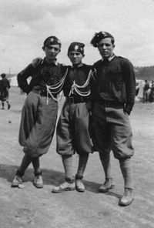

The nickname for knickers/knickerbockers originated in the 19th century, after the fictitious Dutch immigrants who would wear them, but the clothing was worn far before then. The clothing item was essentially breeches, “full and loose, and gathered into a band at the knee;...” It was common for little boys or athletes to wear ( pg.245, 375-376). Women didn’t wear knickers until later in the century, but men wore flannel or tweed pairs ([The Victorian Web](https://victorianweb.org/art/costume/nunn6.html)). They were first brought to the general population for the militia, but then men started wearing them just because. Knickerbockers would be “cut three inches wider in the leg and two inches longer than ordinary breeches.” They were loose-fitting and would be gathered in a band below the man’s knee, and fastened by a buckle/button ([Fashion History Timeline](https://fashionhistory.fitnyc.edu/knickerbockers/)).

(Survey of Historic Costume 6th edition)

1. Levis - Savannah Jeppson

The Levi jean pant originated when Levi Strauss was taking a supply of heavy-duty canvas to San Francisco during the Gold Rush. After hearing many complaints from the miners about how their pants didn’t last long under the rough conditions, he took the opportunity of creating a sturdy work pant from the canvas material. Later he used denim and dyed them blue. The other workers would ask where they had gotten their pants from and the miners said they were “those pants that Levi made for us.” Thus the term Levi’s originated and was used synonymously with blue jeans, or just jeans.

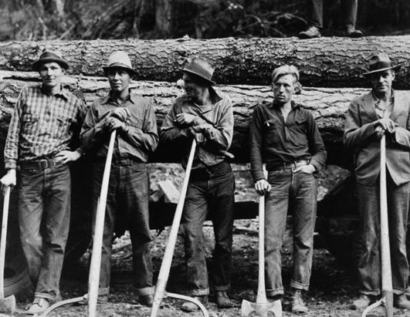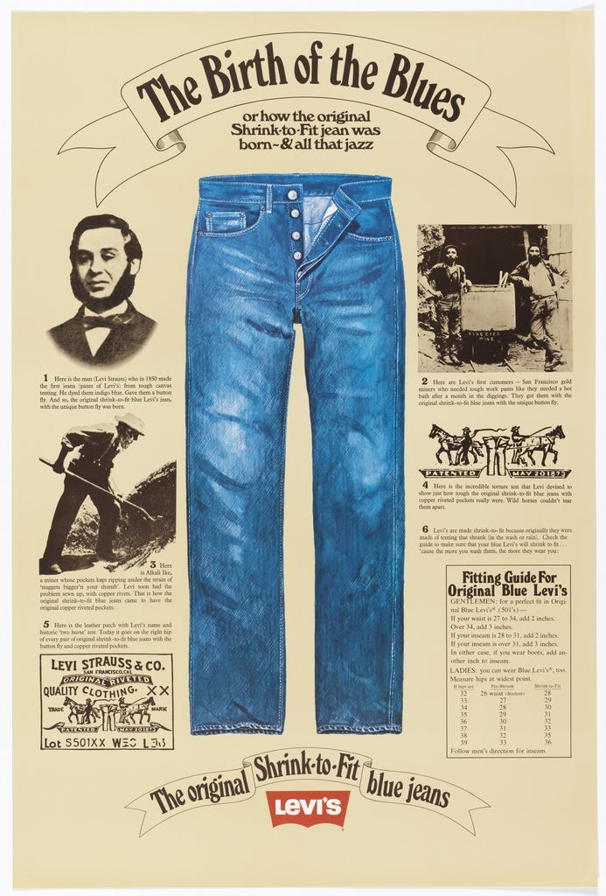

Sources:

The Book: Survey of Historical Costume

<https://abcnews.go.com/Entertainment/slideshow/levis-jeans-miners-models-19217071/image-19217300>

https://www.cooperhewitt.org/2014/02/26/levis-design-stands-the-test-of-time/

1. Lounging Jacket- Bailey Pinder

These jackets were called lounging jackets in England and sack jackets in America. It was a loose and comfortable jacket with no waistline. They had straight fronts, center vents in back, sleeves without cuffs, and small collars with short lapels.The lounging jacket (or sack jacket) is considered the forerunner to the modern suit jacket. They were introduced in the 1860s. Unlike the frock or morning coat, the sack was commonly worn with matching trousers and waistcoat. The sack suit, or lounge suit, was often made in coarser wool fabrics and novelty weaves, or in linen for summer. They were popular because of their ease and comfort.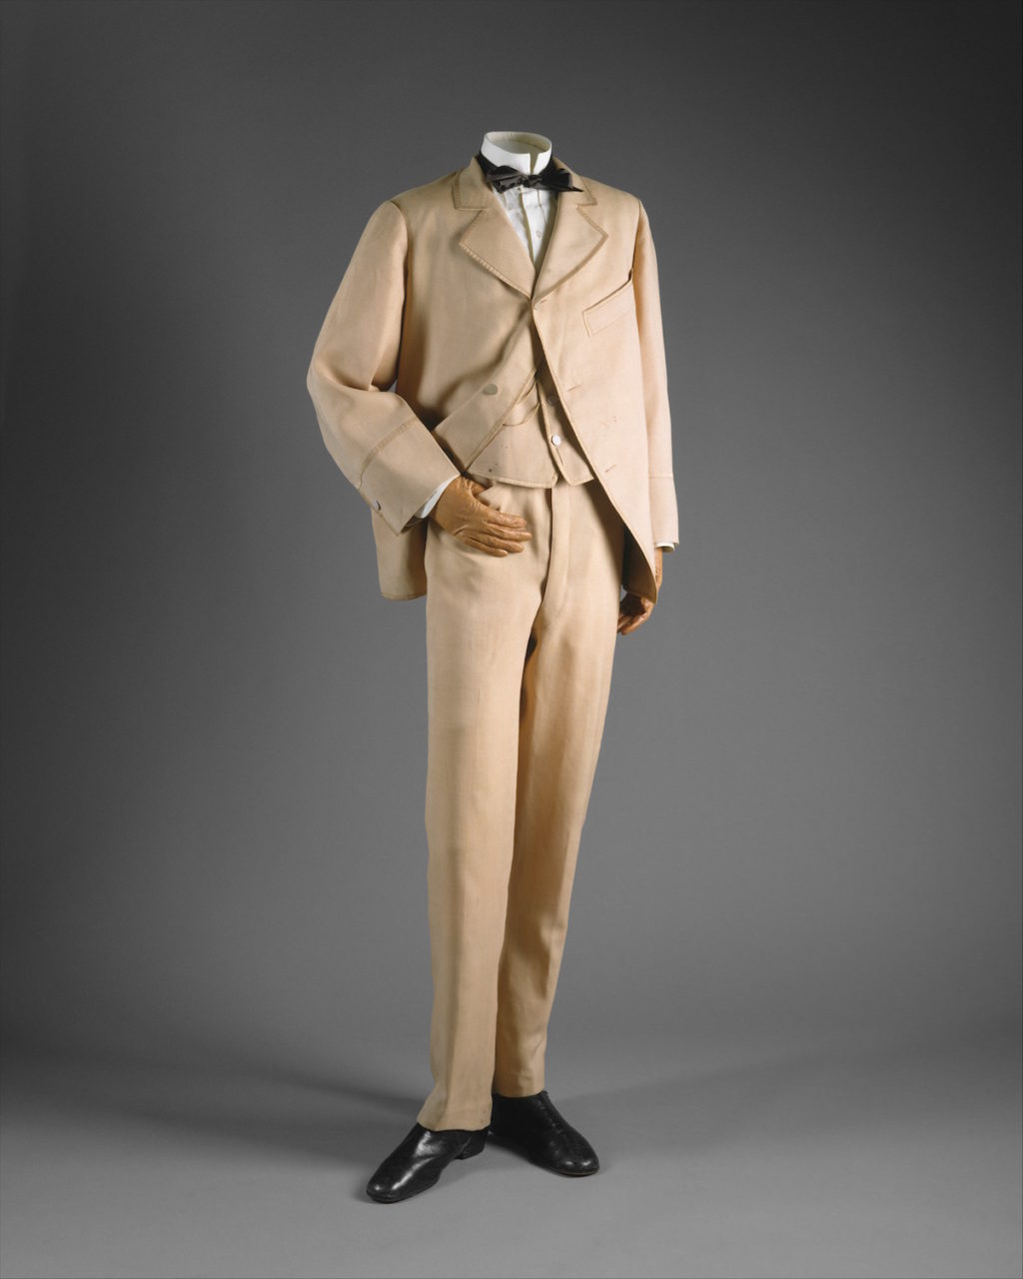

<http://collections.musee-mccord.qc.ca/scripts/viewobject.php?section=18&Lang=1&tourID=VQ_P2_11_EN&seqNumber=8#:~:text=Keys%20to%20History,with%20matching%20trousers%20and%20waistcoat>.

<https://collections.vam.ac.uk/item/O13958/lounge-suit-unknown/#:~:text=The%20lounge%20suit%20first%20appeared%20in%20the%201870's.&text=Summary-,The%20lounge%20suit%20became%20popular%20during%20the%201860s%20because%20of,the%20arm%20to%20the%20waist>.

Survey of Historic Costume, pg 370

1. Middy blouse-Brittany Pocock

The middy blouse could also be known as the sailor blouse. When a little boy was at the age where they wouldn’t dress him like a girl anymore they would dress them in a sailor suit consisting of trousers and a middy blouse. They middy blouse had a square collar and a v-neck opening.

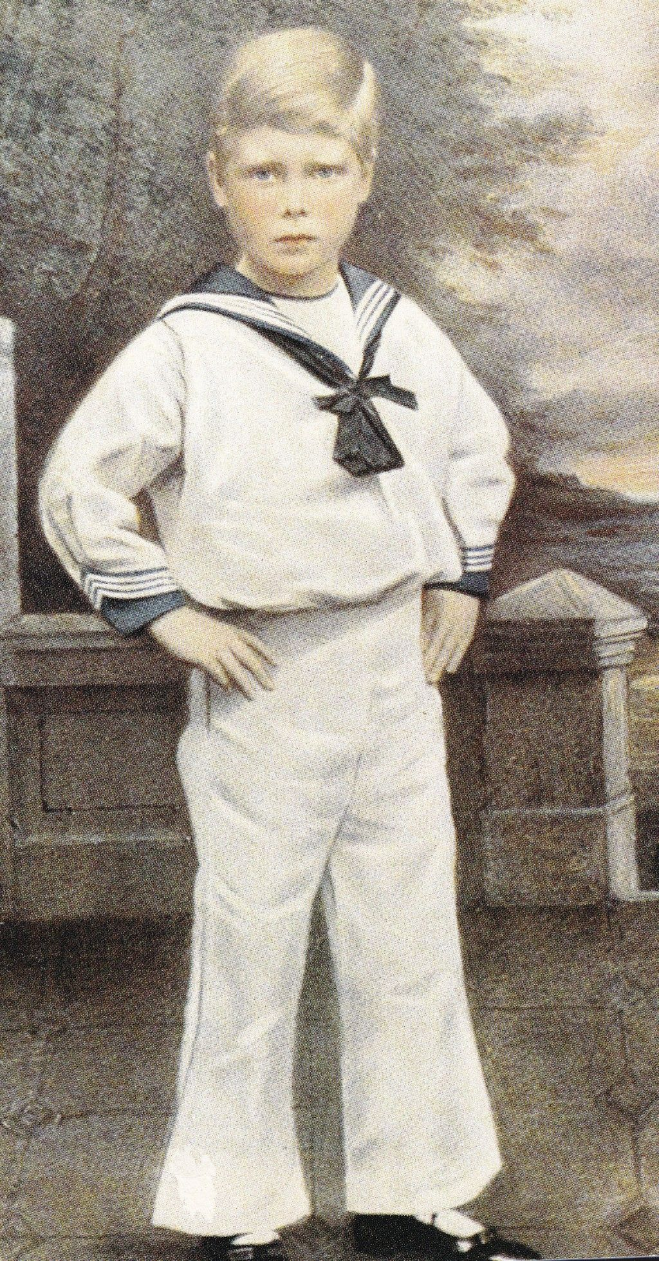

Survey of Historic costume pg 373

[Boy's 1860s Victorian Clothing (victoriana.com)](http://www.victoriana.com/Fashion/boysclothing1860s.htm)

[boys clothes: 1860s (histclo.com)](https://www.histclo.com/chron/c1860.html)

1. Morning Coat - Hailey Child

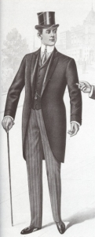

The morning coat has two definitive features that make it a morning coat. These include, the body-coat cut which allows the coat to be fitted more around the waist, and the cut away skirt which makes a curve from the waist to where the hem lies. Commonly worn with morning dress by englishmen. It is also considered one of the most formal wears for a gentleman. Seen often when men would prepare to go horse-riding in the mornings, and over time were worn for formal occasions such as weddings, funerals and political events.

<https://www.whitegloveconsultancy.com/morning-coats-a-brief-history/>

Book

<http://blog.suitopia.com/history/the-morning-coat/>

1. Pagoda Sleeve - Jensen Stenquist

These sleeves were narrow at the shoulder and expanded abruptly to a wide mouth at the end. They were sometimes shorter in front, longer in the back. Some sleeves consisted of double-ruffles, the second ruffle ending about three quarters of the way down the arm. Often an undersleeve was worn under the outer pagoda sleeve. The undersleeve would have been of a lighter weight cotton or linen fabric, matching the bodice’s chemisette or collar. The pagoda sleeve exemplifies the practices of Orientalism and Chinoiserie in 19th-century western fashion, in which fabrics and silhouettes of European and American clothing would be based on Asian clothing and culture.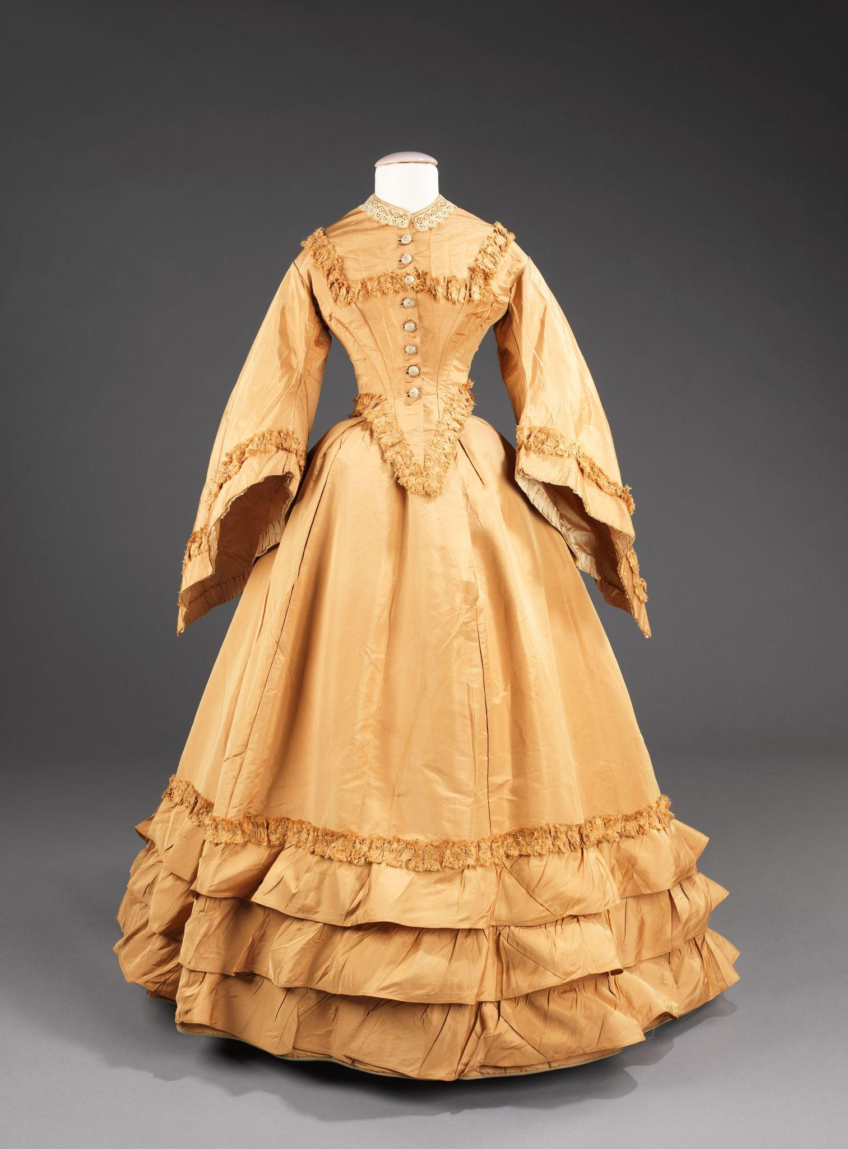

<https://genealogylady.net/2015/08/09/fashion-moment-pagoda-sleeve/>

<https://www.mdhistory.org/dating-101-the-pagoda-sleeve-of-the-mid-19th-century/>

Book, Pg. 363

1. Pea Coat Jacket - Alex Clark

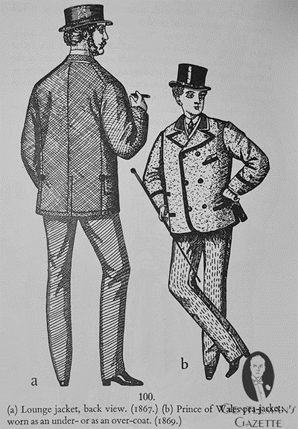

The pea coat jacket was a loose double-breasted jacket that included side vents and a small collar that was worn as an overcoat. They were typically made up of blue wool or witney, which had large buttons in rows on the jacket. The pea coat jacket could also be referred to as a reefer during this time as well and there is another version called a bridge coat which is typically longer in length than the pea coat jacket. The peacoat was typically seen on sailors and the navy for many different countries within history.

Sources

Survey of Historic Costumes, Page 370

<https://en.wikipedia.org/wiki/Pea_coat>

<https://www.gentlemansgazette.com/peacoat-guide-history-sizing-buy/>

1. Pelisse Mantle - Marisa Bone

A Pelisse is a fur-lined robe as a part of a uniform which was originally a short fur trimmed jacket worn on the left shoulder of light cavalry soldiers ostensibly to prevent sword cuts. The Pelisse connected the trends of military styling and exoticism. The fashion was then applied as a fashionable style of a woman's coat worn in the early 19th century. It's seen more today on decorative jackets where one side is more heavily detailed than the other.

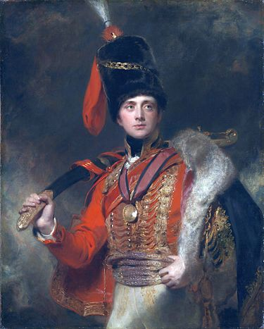

[Source 1](https://en.wikipedia.org/wiki/Pelisse)  [Source 2](https://fashionhistory.fitnyc.edu/pelisse/)

1. Princess Dress-Ida Johnson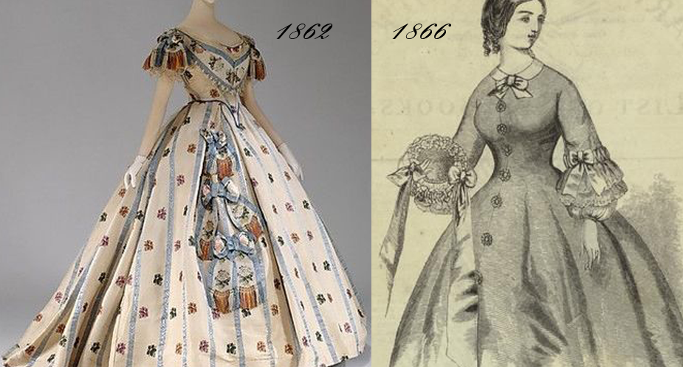

One-piece dress style that was cut without a waistline seam. Long Gored sections, from shoulder to floor, were shaped to fit at the waist through the curve of the cut sections.

Book 365, <https://silhouettescostumes.com/the-new-princess-line-gave-a-sleeker/>

<https://en.wikipedia.org/wiki/Princess_line>

1. Raglan Cape -Abigail Storrer

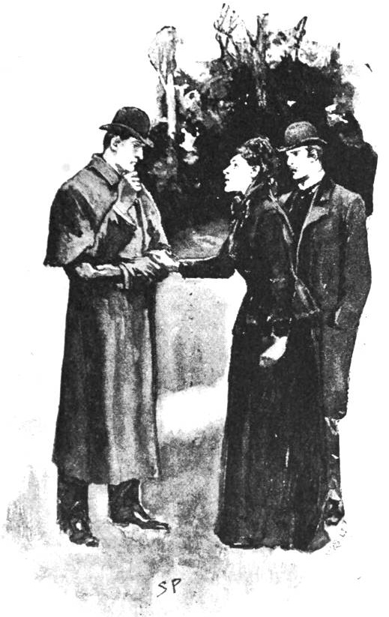

A raglan cape was an overcoat. The reason it was called raglan, is because that was the type of sleeve it had, instead of a set in sleeve. The raglan sleeve is different in that it connects to the bodice front and back at a diagonal angle and goes all the way to the neck. These overcoats were one type that were worn by men outdoors between the 1850’s to the 1870’s. These coats also had an overlap on the front concealing the closure. The sleeves on these coats and the fullness in them allowed much greater movement and comfort.

<https://victorianweb.org/art/costume/nunn24.html>

<https://robbreport.com/style/menswear/history-of-the-raglan-sleeve-coat-2899032/>

Book Pg. 372

1. Reefer Rotonde- Claire Moore

These were loose jackets that were similar to a pea coat. They were usually double breasted with side vents. These coats were worn by men.

Sources 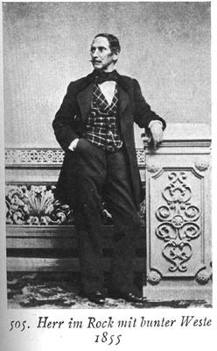

<https://aubreyshuga.wordpress.com/the-crinoline-period-1850-1869/>

<https://lowelldesigns.com/crinoline-mid-victorian/>

1. Sack Jacket- Marisol Dejesus

A sack jacket was an oversize loose jacket with no waistline. It's casual wear and was worn for morning or leisure. The sack jacket has a small collar with short lapels, a center vent at the back, straight fronts, and sleeves without cuffs.

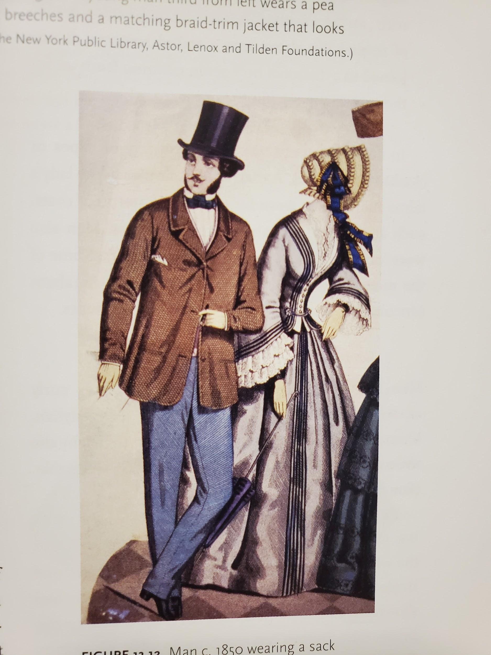

Textbook: 370

<http://walternelson.com/dr/node/198#:~:text=The%20sack%20suit%2C%20walking%20suit,vast%20majority%20of%20American%20men.&text=It%20first%20came%20into%20fashion,more%20fitted%20during%20the%20'60s>.

[https://cawhittakercostume.wordpress.com/2014/01/22/the-boating-suit](https://cawhittakercostume.wordpress.com/2014/01/22/the-boating-suit/)

1. Sailor Suits - Kimberly Moita

Sailor suits were worn by young boys after the age of 5 which was made of trousers or knickers, and a blouse with a flat, square collar and v-shaped neckline. The sailor style was also known as a “middy” derived from the word “midshipman”. It is stated that Queen Victoria started the trend, dressing her princes in the style. The princes wore a scaled down version of a real Royal Navy uniform. In 1846 the prince of Wales portrait was painted onboard their royal yacht and the sailor suit began to attract the interest of English mothers who began dressing their children in the suits.

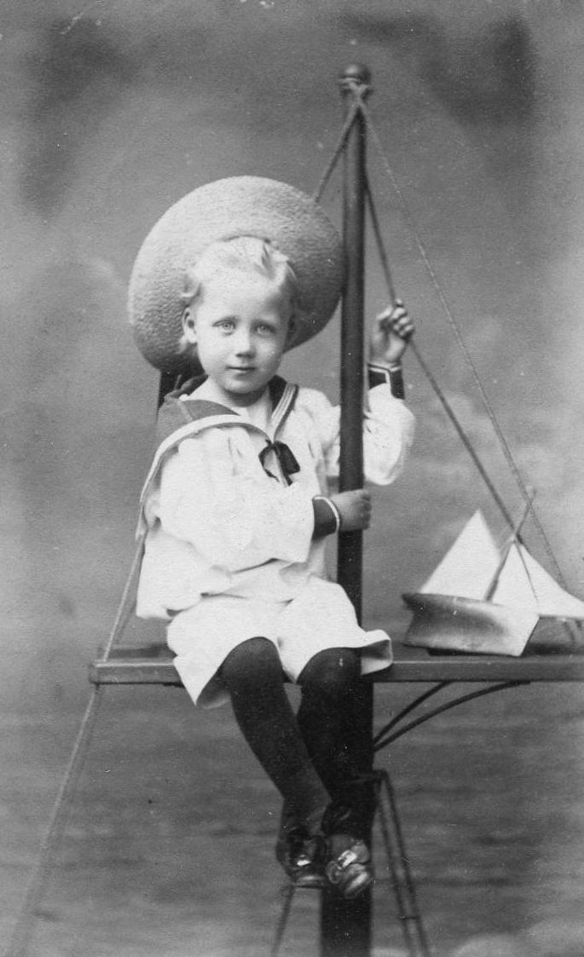

<https://en.wikipedia.org/wiki/Sailor_suit#:~:text=Origins%20and%20history,-In%20the%20Royal&text=It%20is%20primarily%20ceremonial%2C%20although,navies%20from%20around%20the%20world.&text=It%20is%20often%20considered%20lucky%20to%20touch%20a%20sailor's%20collar>.

<https://histclo.com/style/suit/sailor/sailorscoueng.html>

1. Shawl Mantle: Lexie Pincock

A cloak-like piece of clothing that is worn mostly by women over their dress and reaches the skirts and sometimes lower. This shawl in particular reached the hem of the dress. A fashion accessory.

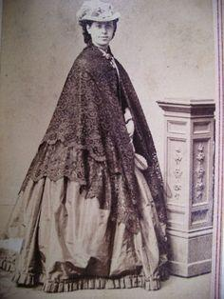

Sources:

Pg 366

<https://www.fibre2fashion.com/industry-article/7147/history-of-women-s-fashion-dress-the-crinoline-period-c-1850-1869>

<https://aubreyshuga.wordpress.com/the-crinoline-period-1850-1869/>

1. Snood- Savannah Tanner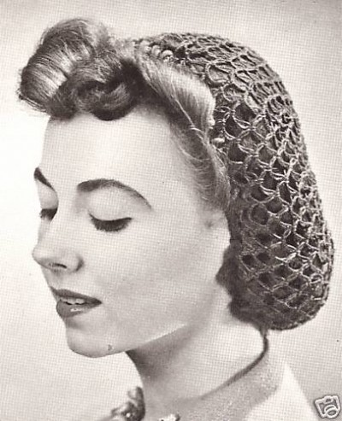

The snood was a hair net, this was worn primarily during the day. The snoods could be made of colored silk or chenille. Snoods were typically the name given in Europe, but hair nets were the more common name in America. We can still see the evolution of these today. They are effective for keeping one’s hair back, out of the face and out of the work. Today, hair nets are primarily fashioned with an elastic band, however they were usually tied with a string back then.

<http://www.elizabethancostume.net/headwear/snood.html>

<https://recollections.biz/blog/what-about-snoods/>

Pg 367

1. Stetson Hat Amanda Taylor

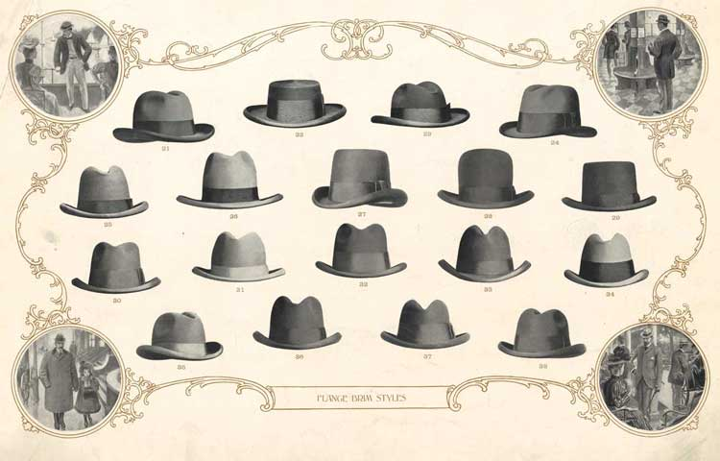

The stetson hat began the cowboy hat craze. The round, curved brim hat with a pinched crown has become one of the staples of western wear. This style began with John B. Stetson, who was a famous hat manufacturer from Philadelphia. In 1865 he designed the “Boss of the Plains” hat. This hat, however, looked quite ordinary compared to what we have today and was made out of fine beaver or rabbit fur. This hat was also incredibly durable making it ideal for the demanding work of a cowboy.

<https://nationalcowboymuseum.org/explore/history-of-the-cowboy-hat/>

Textbook Page 371

<https://en.wikipedia.org/wiki/Stetson>

1. Talma Mantle - Jalissa Cloward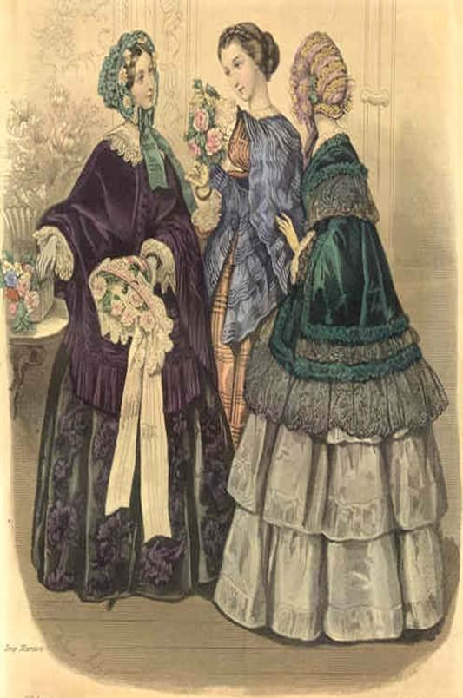

The talma-mantle was a full cloak that had a flat collar or a tasseled hood. The talma-mantle could vary in style. The most elegant ones were made of finer materials, such as velvet and satin.

*Survey of Historic Costume* pg. 366

<https://www.fibre2fashion.com/industry-article/7147/history-of-women-s-fashion-dress-the-crinoline-period-c-1850-1869>

<https://books.google.com/books?id=gUQFAAAAQAAJ&pg=PA194&lpg=PA194&dq=talma+mantle&source=bl&ots=x0LSBOWu3x&sig=ACfU3U2hrTbwt-EOSgWkx6CInLqf3Xgwow&hl=en&sa=X&ved=2ahUKEwiP0JL1gPPpAhUEOn0KHVlGBPkQ6AEwFnoECAkQAQ#v=onepage&q=talma%20mantle&f=false>

1. White kid shoes- Jamie Rakes

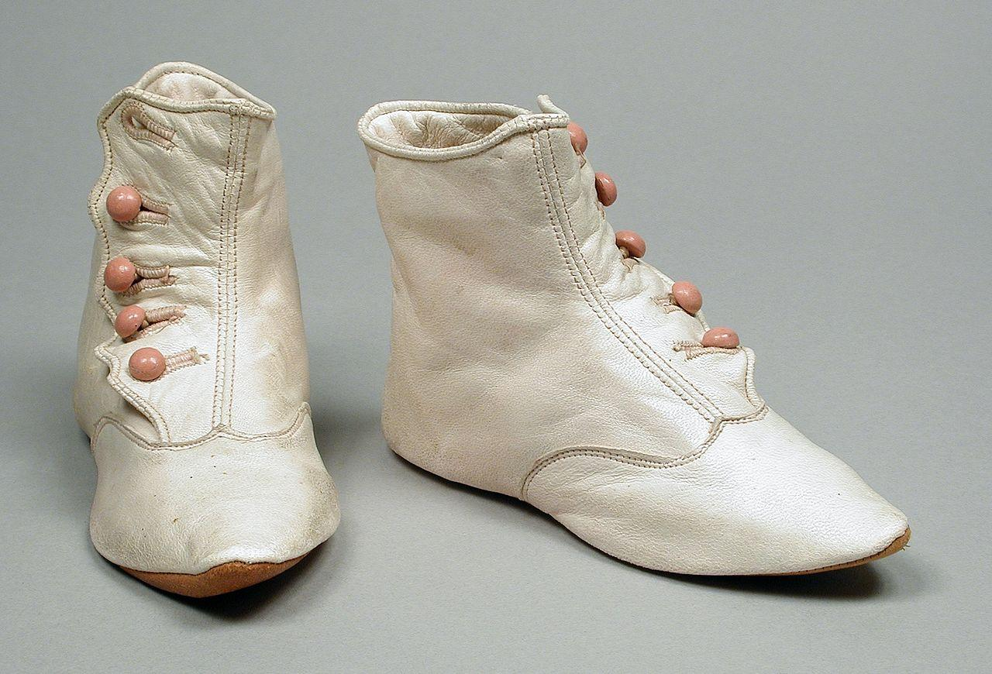

White kid shoes is not what you may think. These shoes were actually an. Evening shoe worn by women that was made out of white kid or satin. These shoes were then dyed to match the color of the dress. White kid is the skin of young goats and specifically for this time period was white.

<https://en.m.wikipedia.org/wiki/Kidskin>

<https://www.studocu.com/en-us/document/miami-university/history-of-western-dress/chapter-13-the-crinoline-period-notes/5930607>

Textbook pg 274

1. Charles Worth - Hannah Ferreira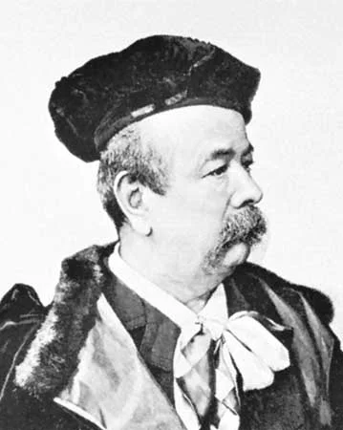

Charles Worth was an Englishman who could claim to be the founder of the French Couture. He didn’t have very much money and he couldn’t speak French, but he moved to Paris to work in the fabric houses. He had his French wife wear the dresses he had designed and there began to be a huge demand for them among the women that saw them styled on his wife. He left his job in 1858 and set up his own establishment. He presented his designs to the Princess Pauline von Metternich, and eventually gained favor of all fashionable Paris. He dressed all of the most respectable and some of the most notorious women in the world. He worked as a couturier until 1880’s when his sons took over the business. 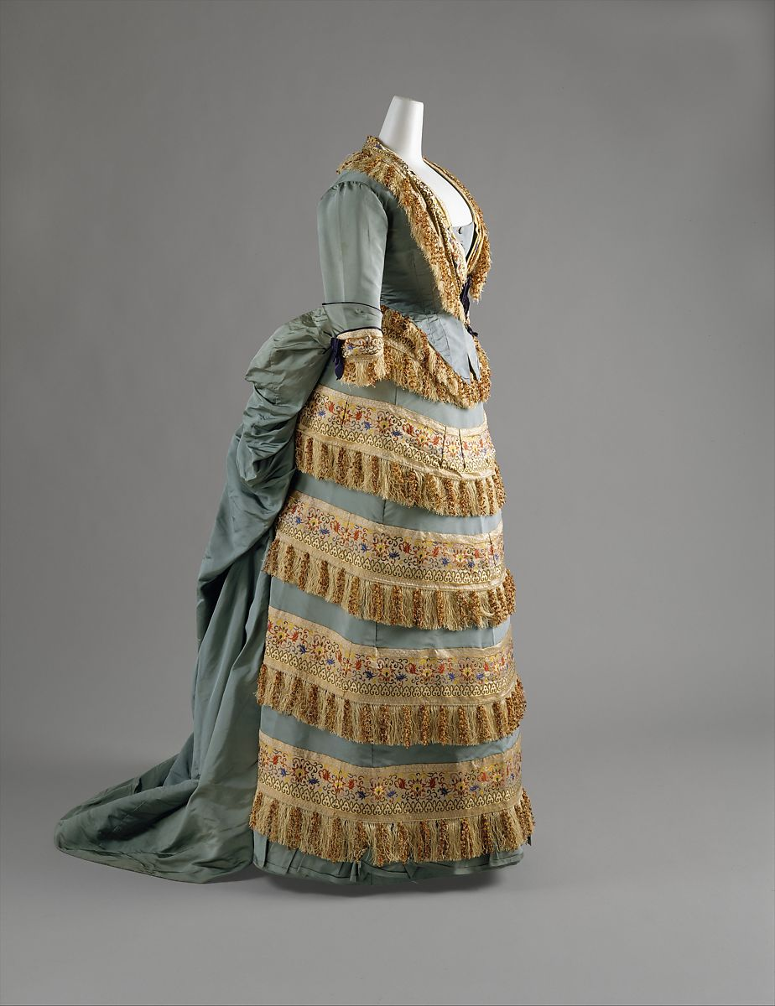

Book pg. 354

<https://www.metmuseum.org/art/collection/search/81112>

<https://www.britannica.com/biography/Charles-Frederick-Worth>

1. Wide Awake (hat) : Elizabeth nathan

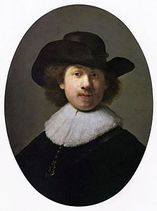

A Wide Awake hat is a broad [brimmed](https://en.wikipedia.org/wiki/Brim_(hat)) [felt](https://en.wikipedia.org/wiki/Felt) "countryman's hat" with a low crown, similar to a [slouch hat](https://en.wikipedia.org/wiki/Slouch_hat). A wide awake hat is most commonly seen in dark shades of cloth, such as dark brown or black felt. The brim is fairly wide, and is flat in front and back but with a moderate upturn on the left and right sides. The brim may be asymmetric from side to side, as seen in the [Rembrandt](https://en.wikipedia.org/wiki/Rembrandt) portrait.

<https://en.wikipedia.org/wiki/Wideawake_hat>

<https://hatguide.co.uk/wideawake-hat/>

1. Zouave - Jocelyn Munoz

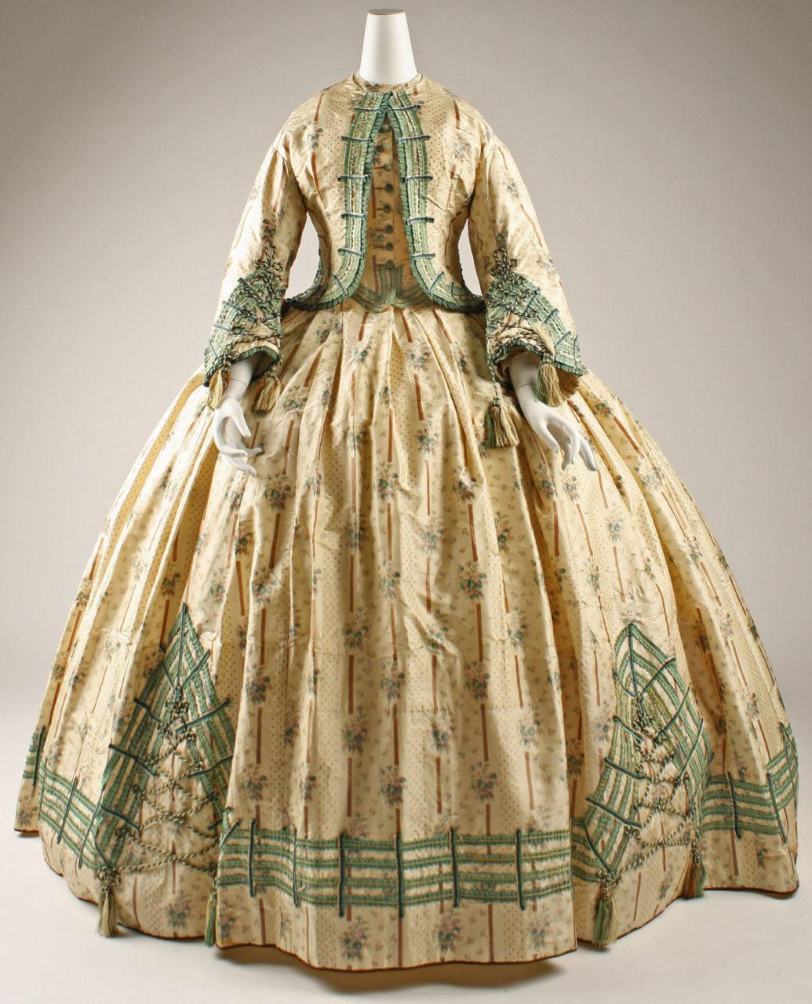

The Zouave was a short collarless jacket that is trimmed with braid. They came from Algerian troops fighting in the french army that were fighting against an African tribe called the Zouaoua. Their popularity really exploded during the U.S. Civil War with a regiment that fought for the North.

https://www.mdhistory.org/the-zouave-jacket-frenzy-in-the-1860s/

https://fashionhistory.fitnyc.edu/1862-cream-and-mint-silk-day-dress/

Tortora, P. G., & Marcketti, S. B. (2021). In Survey of historic costume. essay, Fairchild Books.

1. Parasol - Zaya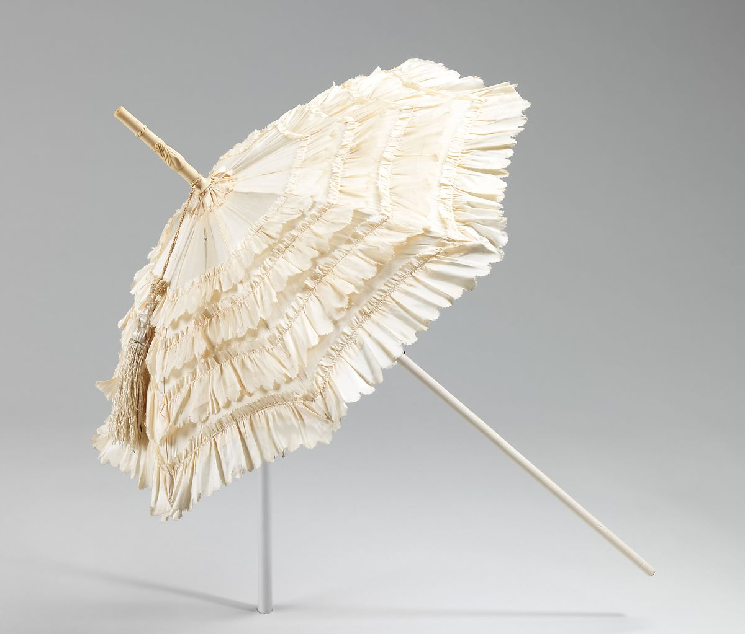

Parasols were very functional accessories that kept the sun off one’s face in hotter weather, but they were also very distinctly a fashion item & were often carried solely for an aesthetic purpose. Parasols of this era were often fairly small & dome shaped. The frames could be made of baleen, wood, reed, or even precious materials such as ivoryl, & Steel came into use around 1860. Covers could be many kinds of textiles like wools, cottons, & linen but silk was very popular. They could be decorated in all kinds of ways, with ruffles, fringe & other methods. Eventually some parasols were made to be foldable for convenience, & some had a hinge so the canopy itself could be tilted at an angle.

It’s technically of a later period than this chapter covers, but I actually own an antique parasol myself that I want to show off briefly. It’s the only antique fashion item I own & the shop labeled it as 1890s.

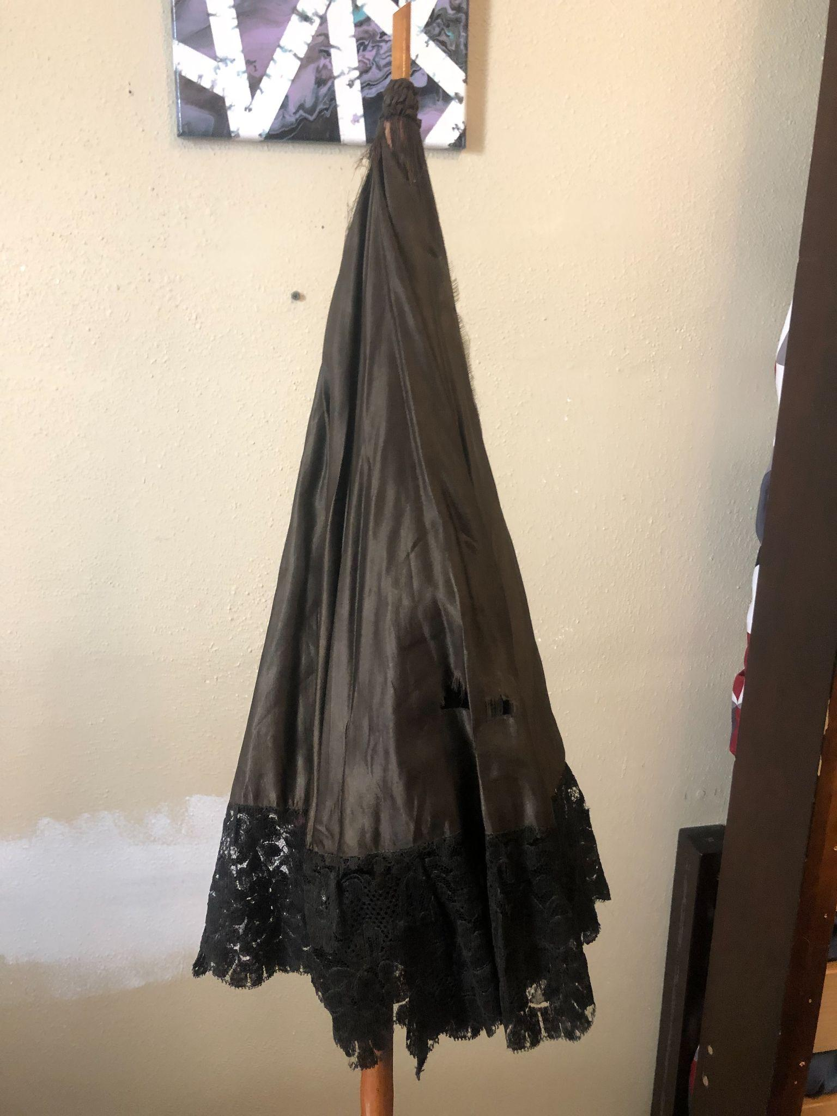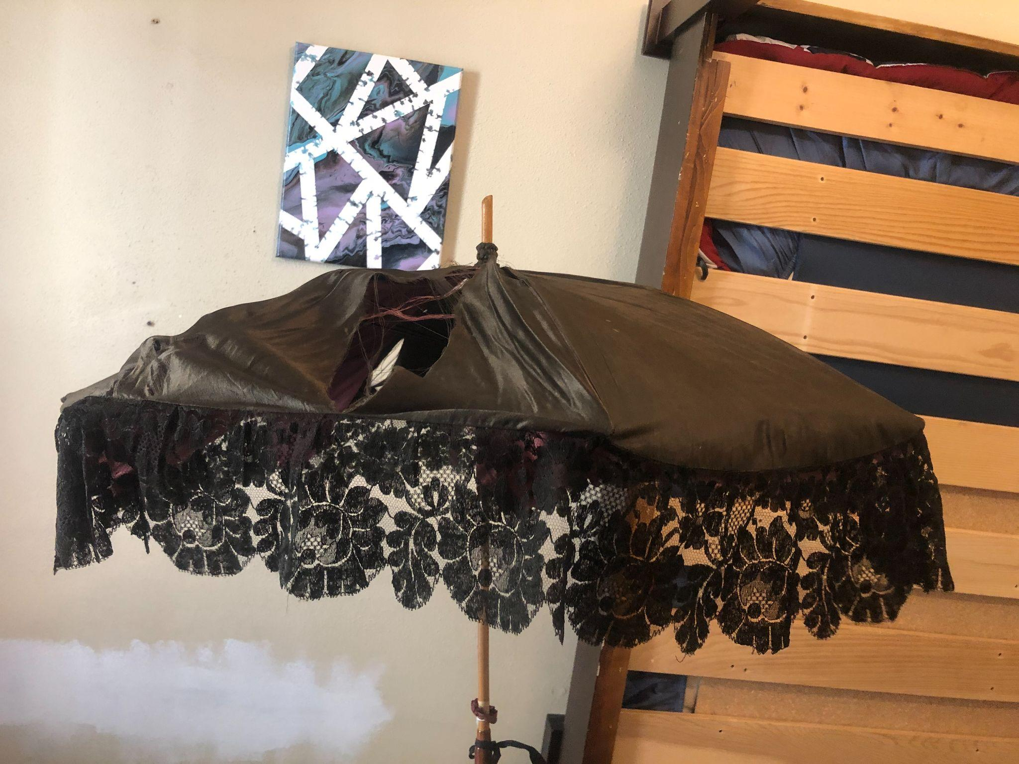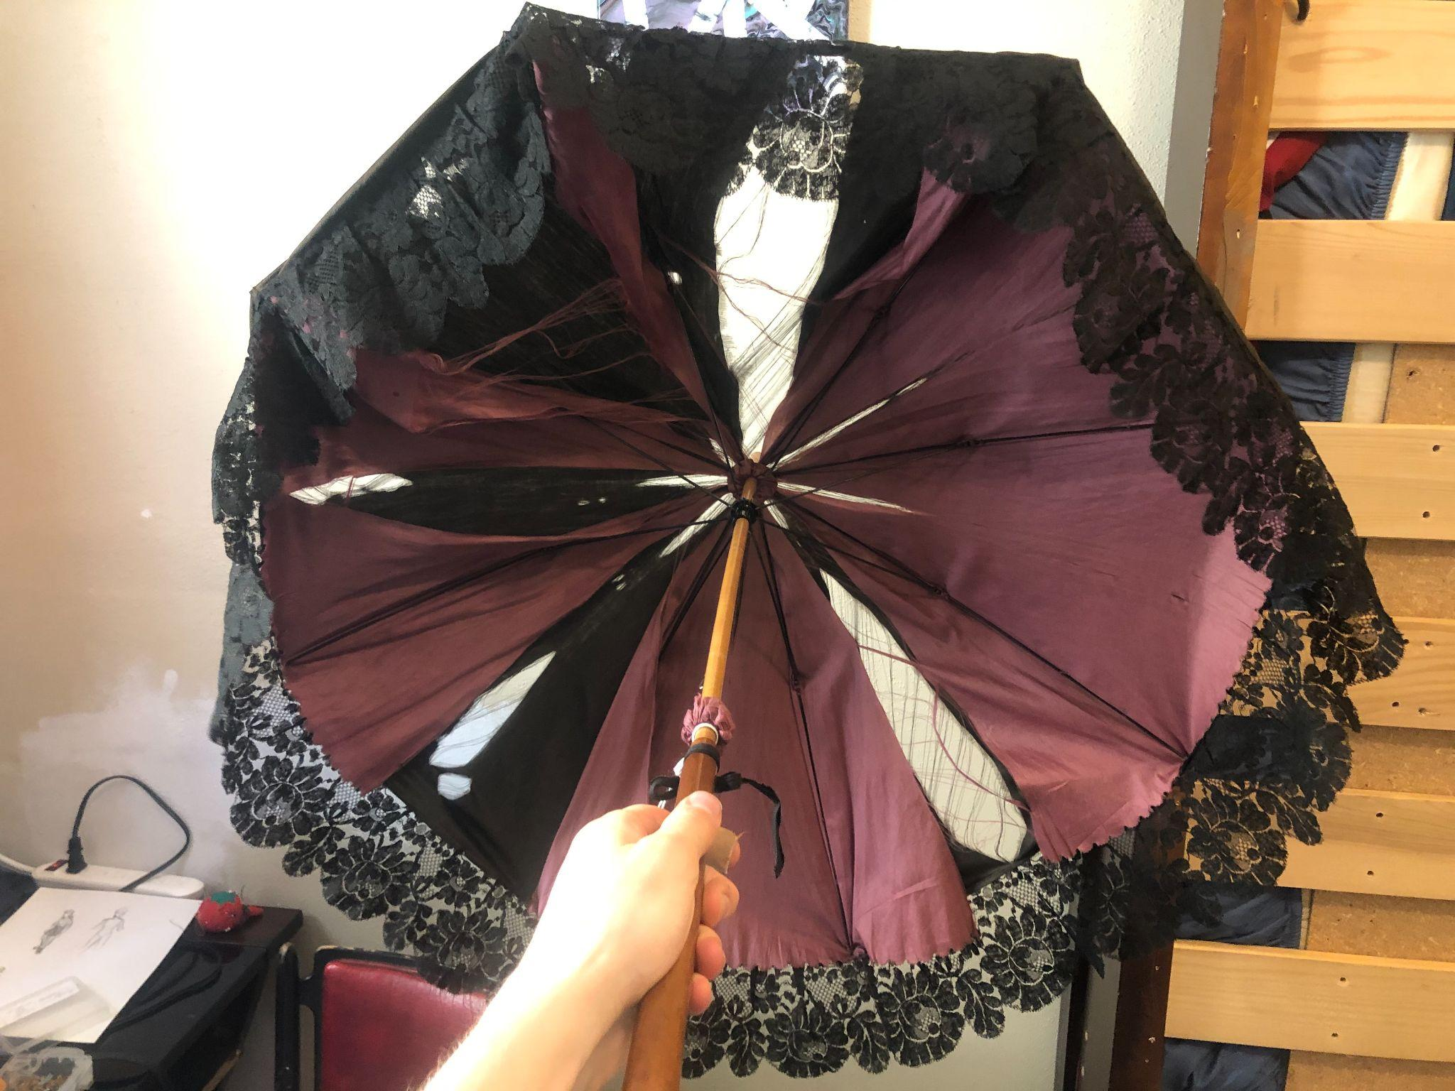

**Sources:**

Survey of Historic Costume- page 367

<https://www.youtube.com/watch?v=mTk7MLgBX0w&t=240>

<http://4thusreenactors.blogspot.com/2016/04/parasols.html>

<https://www.metmuseum.org/art/collection/search/157262>

1. Importance of the “invention of the Sewing Machine” on the Civil War- Andrea Lazaro

By the end of the 19th Century, America entered into a time of increased economy and inventions. The first great invention that took place in America was the sewing machine, that happened even before the invention of typewriters or automobiles. The sewing machine became a symbol of women’s labor. Singer sewing machines were the first machines that started to sell well, partly because of the sales methods of Isaac Singer (inventor), which helped the economy. Sewing machines proved to be useful especially during the American Civil War when ready-to-wear clothes were more necessary. Sewing machines accelerated the process of production, and increased mass production of clothing.

Sources:

Survey of Historic Costume p. 358

​​<https://millmuseum.org/sewing-revolution/>

<https://www.farmanddairy.com/columns/how-the-sewing-machine-transformed-society/617598.html>

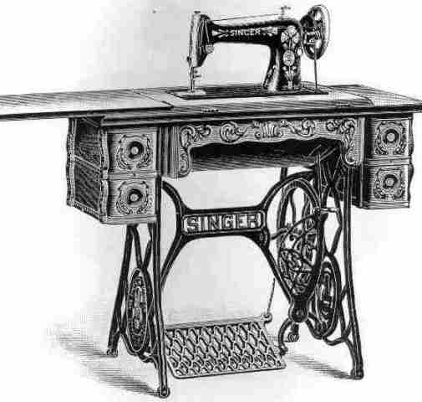

1. ZUAVE: Madison Frost

This was a type of uniform that was used in the Civil War. It consisted of a vest, jacket, sash baggy trousers, and fez. The Zouave was a class of french infantry soldiers linked to French North Africa. They are some of the more decorative units of the French Army.

